Kaveri Travels[1]

“Most of our customers say that the time taken to book our jungle lodges is deplorably high. I would like to know what we can do about it”, said Rohan, managing director of Kaveri Travels. Rohan is discussing the results of the recent customer satisfaction survey with his management team. Kaveri Travels operates a number of jungle lodges in Karnataka, Uttaranchal and Madhya Pradesh. They have recently commissioned a customer satisfaction survey, the results of which are being discussed now.

While Kaveri Travels have offices at various locations in order to manage and maintain the jungle lodges, their sales strategy is completely Web driven. Customers can book their stay at any of the lodges only through their website. They advertise on different search engines (SEs) and when the customers click on the advertisement, they are automatically taken to the website where booking can be done. The website also provides detailed information on the lodges. They also have a tie-up with a voice call centre which will provide guidance in booking the stay whenever customer call.

“I think the time taken to book depends on the search engine used by the customers”, suggested Rajeev, Manager Finance and Accounts. “I was experimenting with Boogle the other day and it took almost five minutes to complete the booking”. Swetha begged to differ. Swetha is Manager, Information Systems and Information Technology. She opined that the time taken for booking has nothing to do with the search engine, and that it depends on the behaviour of their own website. “It also depends on the speed of the connectivity at the customers’ end. It takes a long time if they are using a low speed modem or a bad service provider. We can at least ensure that it is fast enough from our end”, she said. She had been wanting to optimise the website such that it becomes faster as well as appears on the top of the search results in all the search engines. She had proposed a major revamp of the website along with additional investment in cloud based services for hosting the website with faster response. The rest of the management team is not very enthusiastic about her proposal. They had been arguing that the occupancy rate is around 80 percent, even during winter time and is much better than that of the competitors. They feel that under such circumstances, investing in upgrading of the website is unnecessary and a waste of resources.

“We do spend lot of money in advertising on different search engines. We have to find out if there is a problem with any of them and we should take remedial action. I don’t see any reason why we should continue to spend money with any SE which is creating problems for us”, said Rohan. Rajeev responded immediately saying that they should drop Boogle from their list of SEs, quoting his personal experience. Karthik, Manager, Operations said, “How can you take a major decision like that based on one single instance?” Karthik is known for his analytical mind and is completely data-driven. He suggested that they should commission another survey focussing on the search engines and the time taken for booking the stay. Rajeev felt that it is too early to commission another survey, not to mention the cost involved.

Swetha suggested that she can get the data without any additional cost. She said, “We have the required data on our servers. We know who the referrer was, the exact time at which any customer reaches our website and the time at which the transaction is completed. All this information is available within our click-stream data. We just need to extract it. We can get as much data as you want. I can do it in a jiffy, but I am not sure about the kind of analysis that will lead us to the right conclusions”.

Karthik immediately came forward with a suggestion. He said that he remembered some technique from his MBA days, which can prove, with some reasonable doubt (*probably, he meant “beyond reasonable doubt”*), whether the time taken for booking is independent of the search engine. He asked Swetha to pull out the required data from the server web logs and summarize it the way he wanted.

Swetha and Karthik met later in the afternoon and Karthik suggested that she take last week’s click-stream data on bookings. He wanted her to categorize the time taken for booking into four categories as follows:

* Fast (less than 1 minute)
* Medium (1 to 2 minutes)
* Slow (2 to 4 minutes)
* Long (more than 4 minutes)

They also decided that they need to look at just three search engines which, together, contribute to most of their bookings. These are Boogle, Cahoot and Altrue Vista.

Swetha summarized the data, as shown below, and sent it to Karthik.



Prob that he came from Altrue P(A) = 70/200

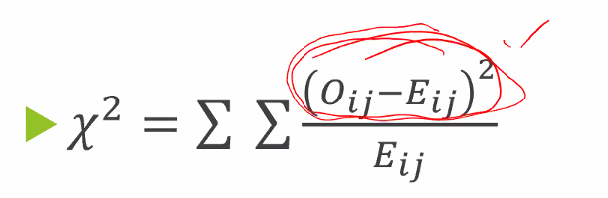

I can standardize it using either Eij or Oij. Why Eij?

1. H0 is set that the null hypothesis is true. Eij is measured keeping in mind H0 is true. So its standardized.
2. Also Oij can be 0. Eij cannot be 0.

1. Vishnuprasad Nagadevara, Indian Institute of Management Bangalore